**Library Space Usage Study – November 2020**

Data Analyzed by *Bekzod Normatov*

17 December 2020

1. **Summary of statistics for 01 November – 30 November 2020**

The expected number of data entries for this report was 261, whereas the received number of data entries was 150. With 111 missing entries, the percentage of missing data entries is 42.53%. Given that this percentage was 37.78% in the previous month, the percentage of missing data entries increased by 4.75%. The other observation is that there are only 17 missing entry (out of 111) during the weekends. The implication is that during the weekday shifts, SAs tend to neglect to do the space study survey more often.

1. **Methodology**

All the findings in this report are represented with percentages. The individual capacities of different spaces are shown in the table below. Because of COVID-19, social distancing measures are taken at the Library, and thus capacity of each space is nearly halved. The individual capacities of different spaces during this period are:

|  |  |
| --- | --- |
| **Space** | **Capacity** |
| Level 1 | 24 |
| Stacks | 16 |
| GSR1-3 | 6 |
| Level 2 | 15 |
| GSR4-5 | 4 |
| Computer Lab | 26 |
| 24H | 29 |
| **GRAND TOTAL** | **120** |

For some analysis, the main focus is on 4 main spaces which are:

|  |  |
| --- | --- |
| **Space** | **Capacity** |
| Level 1 | 24 |
| Stacks | 16 |
| Level 2 | 15 |
| 24H | 29 |
| **GRAND TOTAL** | **84** |

1. **Occupancy Statistics – All Months**

**Total Library (All spaces) Occupancy by Hour**

**Weekday Statistics Highlights**

Average Max/Min:

August Maximum: 2pm (29.36%)

August Minimum: 12pm (11.58%)

September Maximum: 2pm (26.25%)

September Minimum: 7pm (12.29%)

October Maximum: 4pm (28.02%)

October Minimum: 7pm (12.12%)

November Maximum:

November Minimum:

Individual Max/Min:

August Max:

12 August 2pm (41.67%)

11 August 10am (36.67%)

19 August 4pm (34.17%)

13 August 2pm (33.33%)

20 August 2pm (33.33%)

August Min:

21 August 10pm (6.67%)

27 August 7pm (6.67%)

13 August 10pm (5.83%)

10 August 8pm (5.00%)

14 August 12pm (5.00%)

September Max:

03 September 2pm (42.50%)

01 September 2pm (39.17%)

16 September 2pm (38.33%)

02 September 2pm (36.67%)

08 September 10am (36.67%)

September Min:

25 September 8pm (3.33%)

25 September 10pm (3.33%)

22 September 10pm (2.50%)

23 September 12pm (2.50%)

23 September 7pm (2.50%)

**Weekend Statistics Highlights**

Average Max/Min:

August Maximum: 4pm (20.33%)

August Minimum: 11am (6.67%)

September Maximum: 5pm (22.08%)

September Minimum: 11am (6.11%)

October Maximum: 3pm (20.24%)

October Minimum: 11am (5.69%)

November Maximum:

November Minimum:

Individual Max/Min:

August Max:

16 August 4pm (26.67%)

16 August 2pm (25.83%)

16 August 3pm (25.83%)

23 August 4pm (21.67%)

23 August 5pm (20.83%)

August Min:

30 August 12pm (7.50%)

16 August 11am (5.83%)

23 August 11am (5.00%)

22 August 11am (4.17%)

22 August 12pm (4.17%)

September Max:

06 September 5pm (30.83%)

13 September 4pm (30.00%)

06 September 4pm (28.33%)

06 September 3pm (27.50%)

27 September 5pm (26.67%)

September Min:

20 September 11am (5.83%)

19 September 11am (4.17%)

19 September 12pm (4.17%)

26 September 11am (3.33%)

19 September 6pm (0.83%)

October Max:

14 October 2pm (35.83%)

07 October 2pm (35.00%)

05 October 2pm (34.17%)

27 October 2pm (34.17%)

26 October 4pm (33.33%)

October Min:

13 October 12pm (6.67%)

27 October 7pm (6.67%)

15 October 12pm (5.83%)

23 October 10pm (5.83%)

30 October 10pm (2.50%)

November Max:

11 November 2pm (40.00%)

18 November 2pm (38.33%)

02 November 4pm (37.50%)

09 November 4pm (36.67%)

16 November 4pm (36.67%)

November Min:

17 November 9pm (8.33%)

13 November 10pm (6.67%)

17 November 10pm (6.67%)

04 November 12pm (5.00%)

13 November 9pm (5.00%)

October Max:

04 October 3pm (27.50%)

04 October 2pm (25.83%)

11 October 2pm (25.00%)

25 October 3pm (24.17%)

04 October 5pm (23.33%)

October Min:

24 October 11am (5.83%)

31 October 12pm (5.83%)

10 October 11am (5.00%)

18 October 11am (5.00%)

31 October 11am (4.17%)

November Max:

22 November 2pm (34.17%)

22 November 4pm (33.33%)

22 November 3pm (31.67%)

22 November 1pm (29.17%)

22 November 5pm (29.17%)

November Min:

07 November 12pm (7.50%)

29 November 12pm (5.83%)

01 November 11am (5.00%)

14 November 11am (5.00%)

07 November 11am (4.17%)

**Total Library (4 Main spaces) Occupancy by Hour**

**Weekday Statistics Highlights**

Average Max/Min:

August Maximum: 2pm (27.01%)

August Minimum: 7pm (10.85%)

September Maximum: 5pm (23.46%)

September Minimum: 7pm (9.67%)

October Maximum: 2pm (23.81%)

October Minimum: 7pm (9.86%)

November Maximum:

November Minimum:

Individual Max/Min:

August Max:

11 August 2pm (39.29%)

12 August 2pm (38.10%)

18 August 2pm (34.52%)

10 August 2pm (29.76%)

19 August 4pm (29.76%)

August Min:

21 August 8pm (3.57%)

28 August 10pm (3.57%)

14 August 10am (2.38%)

14 August 8pm (2.38%)

13 August 10pm (0.00%)

September Max:

01 September 2pm (40.48%)

07 September 2pm (34.52%)

03 September 2pm (32.14%)

14 September 4pm (32.14%)

16 September 2pm (32.14%)

September Min:

23 September 8pm (1.19%)

23 September 10pm (1.19%)

25 September 8pm (1.19%)

25 September 10pm (1.19%)

23 September 9pm (0.00%)

**Weekend Statistics Highlights**

Average Max/Min:

August Maximum: 4pm (21.23%)

August Minimum: 11am (5.95%)

September Maximum: 5pm (18.85%)

September Minimum: 11am (5.16%)

October Maximum: 4pm (18.71%)

October Minimum: 11 am (5.27%)

November Maximum:

November Minimum:

Individual Max/Min:

August Max:

16 August 2pm (32.14%)

16 August 3pm (30.95%)

16 August 4pm (30.95%)

23 August 5pm (27.38%)

23 August 4pm (26.19%)

August Min:

23 August 11am (5.95%)

30 August 12pm (5.95%)

16 August 11am (4.76%)

22 August 1pm (4.76%)

22 August 11am (3.57%)

September Max:

06 September 5pm (27.38%)

13 September 4pm (22.62%)

27 September 5pm (22.62%)

06 September 4pm (21.43%)

20 September 2pm (21.43%)

September Min:

19 September 11am (4.76%)

06 September 11am (3.57%)

20 September 11am (3.57%)

26 September 11am (2.38%)

19 September 6pm (1.19%)

October Max:

21 October 4pm (34.52%)

27 October 2pm (34.52%)

05 October 2pm (29.76%)

13 October 2pm (29.76%)

14 October 4pm (29.76%)

October Min:

02 October 8pm (3.57%)

15 October 12pm (3.57%)

23 October 10pm (3.57%)

09 October 10pm (1.19%)

30 October 10pm (1.19%)

November Max:

18 November 2pm (40.48%)

17 November 2pm (35.71%)

16 November 4pm (34.52%)

10 November 2pm (33.33%)

19 November 2pm (32.14%)

November Min:

13 November 10am (5.95%)

04 November 12pm (3.57%)

12 November 7pm (3.57%)

13 November 8pm (2.38%)

04 November 10am (0.00%)

October Max:

25 October 3pm (26.19%)

04 October 2pm (25.00%)

04 October 3pm (25.00%)

04 October 5pm (25.00%)

25 October 2pm (25.00%)

October Min:

18 October 11am (4.76%)

24 October 11am (4.76%)

11 October 11am (3.57%)

31 October 11am (3.57%)

31 October 12pm (3.57%)

November Max:

22 November 2pm (35.71%)

22 November 3pm (35.71%)

22 November 4pm (35.71%)

22 November 1pm (30.95%)

22 November 5pm (28.57%)

November Min:

28 November 11am (5.95%)

07 November 11am (4.76%)

07 November 12pm (4.76%)

14 November 11am (4.76%)

01 November 11am (2.38%)

**Total Library Occupancy by Month**

**Level 1 Occupancy**

**Stacks Occupancy**

**GSR 1-3 Occupancy**

**GSR 4-5 Occupancy**

**GSR 6-7 Occupancy**

**Level 2 Occupancy**

**Computer Lab Occupancy**

**24H Occupancy**

1. **Occupancy Statistics – November 2020**

**Library Spaces Occupancy by Hour**

**Threshold for Figures 25-32**

The figures 25-32 include information on “occupied by belongings”. In order to highlight the worrying data, a threshold is used.

“Occupied by belongings” does not necessarily indicate that people intentionally leave their stuff in order to occupy these seats. Students might go for bathroom or go for filling their water bottles (which are acceptable). It is unrealistic to expect to have “occupied by belongings” 0%.

After a discussion with Sarah Ruslan, we decided that it is okay to expect 1 out of 6 students to leave their seats for an acceptable reason (which corresponds to 16.67%). However, if the “occupied by belongings” is higher than this, it indicates that some students are leaving their belongings intentionally to occupy the seats for their future use. Therefore, when “occupied by belongings” is greater than or equal to 16.67% (the threshold) of “total occupancy”, it is indicated in the threshold check section.

This threshold can be adjusted if required in future.

**Four Main Spaces Occupancy**

*Threshold check*

Weekday Level1 🡪 Occupied by belongings is 18.82% of total occupancy

Weekend Stacks 🡪 Occupied by belongings is 16.86% of total occupancy

**Level 1 Occupancy**

*Threshold check*

Weekday SS_L1 🡪 Occupied by belongings is 24.14% of total occupancy

**24H Occupancy**

*Threshold check*

Weekday IS_24h 🡪 Occupied by belongings is 16.88% of total occupancy

Weekend IS_24h 🡪 Occupied by belongings is 18.69% of total occupancy

SoftSS_24h 🡪 Occupied by belongings is 33.39% of total occupancy

**Level 2 Occupancy**

*Threshold check*

Weekday SS_L2 🡪 Occupied by belongings is 18.76% of total occupancy

**Most Popular Seats**



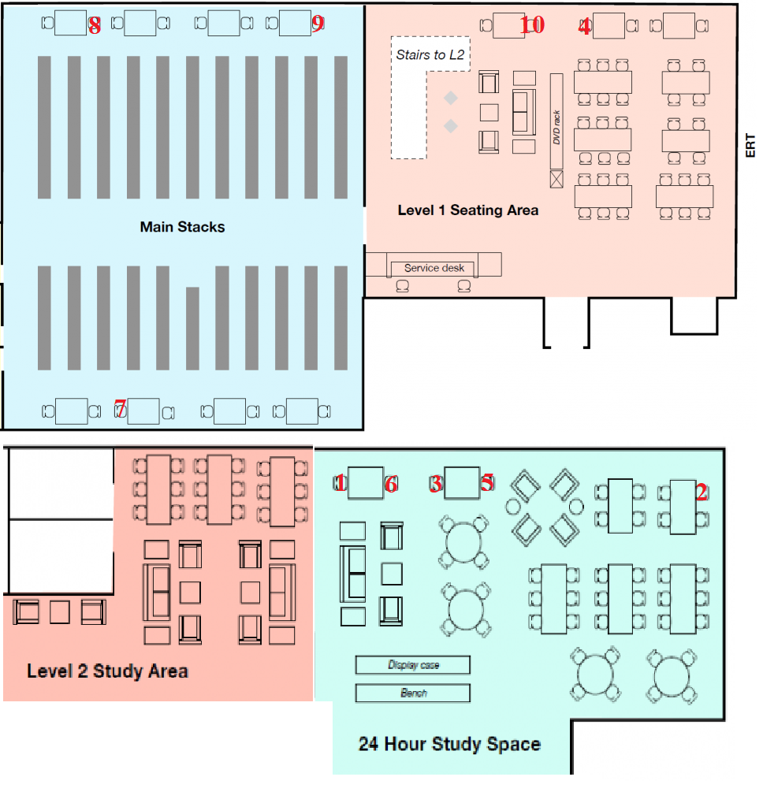

**Least Popular Seats**



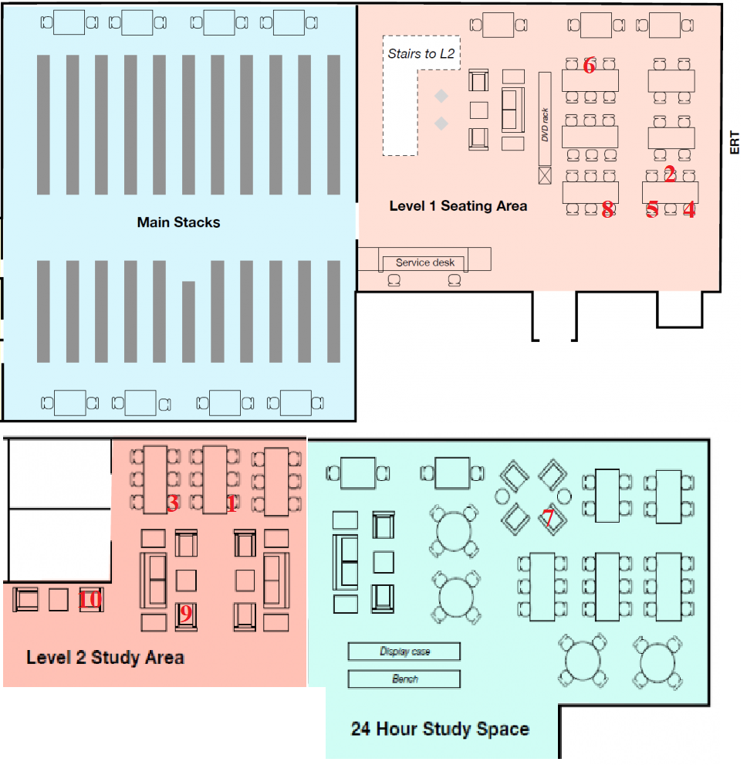

1. **Extended Hours**
2. **Additional Comments on Data**

It is observed that some spaces rarely are more crowded than their capacity. Since the difference between the entered numbered and the capacity is not very significant, it can be concluded that some students take extra chairs from some other places in order to use these space. The “Over Capacity” errors while processing the data are listed below:

(GSR2)

Date: 2020-11-04 10:28:26 Shift: WEEKDAY - 10am

Capacity: 2 Entered: 3

-

(GSR2)

Date: 2020-11-09 16:01:36 Shift: WEEKDAY - 4pm

Capacity: 2 Entered: 3

-

(GSR4)

Date: 2020-11-15 16:04:18 Shift: WEEKEND - 4pm

Capacity: 2 Entered: 3

-

(GSR3)

Date: 2020-11-22 17:01:52 Shift: WEEKEND - 5pm

Capacity: 2 Entered: 3

-

(GSR5)

Date: 2020-11-25 21:08:58 Shift: WEEKDAY - 9pm

Capacity: 2 Entered: 3